**Hands-On Lab/Demo Script**

**Java Development on Linux with Visual Studio Team Services**

# Exercise 1: Creating your Visual Studio Team Services account and Team project

Lab version: 1.1.0

Last updated: 3/7/2016



## Creating your Visual Studio Team Services account

This exercise will walk you through the steps to creating your Visual Studio Team Services account and create a new project. **If you already have a VSTS account, you can skip a few steps and jump to step 13.** Before you do step 13, you’ll need to log in to your VSTS account and start the New Team Project wizard. You can then follow the steps (the instructions assume you’re creating an account *and* a Team Project at the same time but that’s not mandatory—you just need an account in which you have Project Collection Administrator permissions).

Depending upon whether or not you have an MSDN Subscription, and whether you’ve tried Visual Studio Team Services before, you can get started a few ways. Regardless, you’ll need a valid Microsoft Account or already linked Organizational Account to move forward.

1. Login to the virtual machine.
2. Start the Firefox web browser.
3. If you don’t have an existing Microsoft account that you want to use, visit <http://www.outlook.com> to create a Microsoft Account and optionally get yourself a free personal e-mail address. If you have a Microsoft account you want to use, just continue to the next step.
4. Navigate to <http://www.visualstudio.com>.
5. In the upper right-hand corner, click the **Sign In** link.

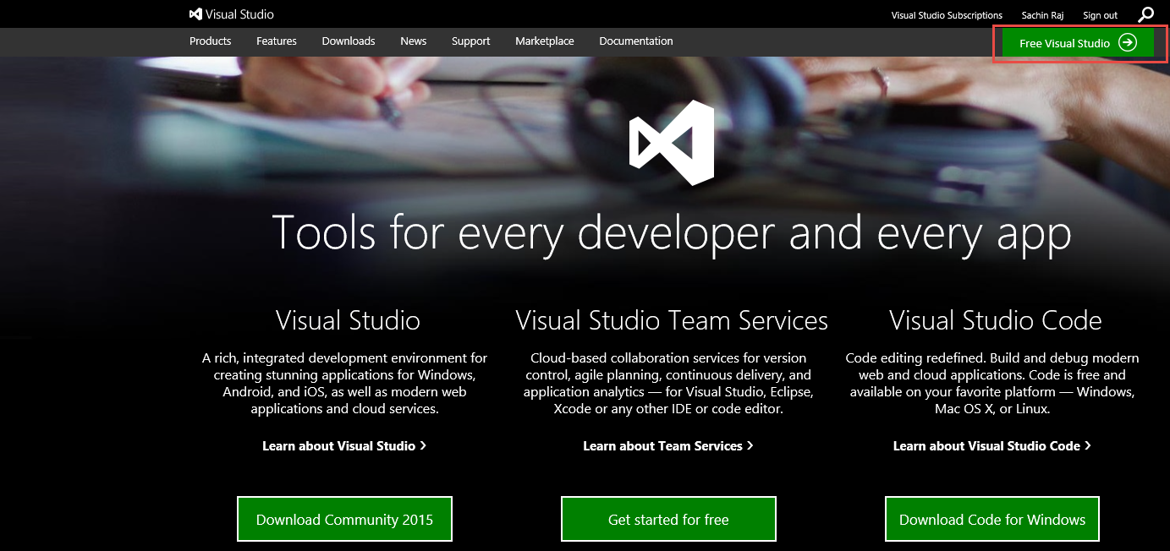

1. The site redirects you to a log in page like the following if you’re not already logged in (If you don’t see the following screen continue to the next step). Enter your e-mail address for your Microsoft account and its password and click **Sign in**.

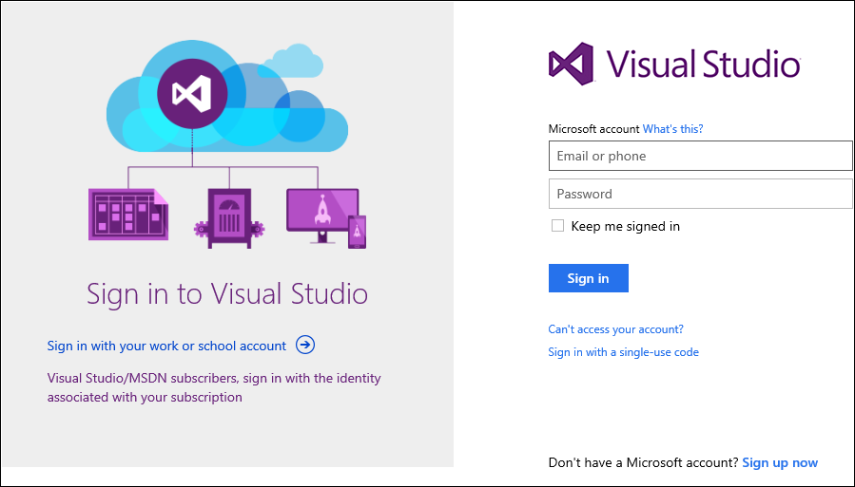

1. Once you’ve logged in, you might be greeted with a page (if not, jump to the next step), like the following, that will allow you to confirm your **display name**, **contact e-mail**, and your **country/region**. Once you set this information, you can change it later. Under the **Hello,** field, enter your first and last name. If you want to receive e-mail notifications from Visual Studio Team Services at a different e-mail address than the one associated with your Microsoft account, change the address shown under the **We’ll reach you at:** field. Click **Continue**.

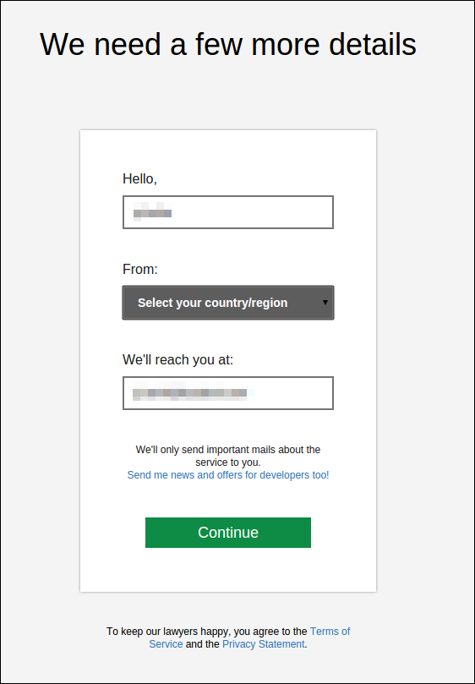

You should now be at the **My Information** page. You’ll jump from here to the account creation process.

Please continue reading before making choices.

When you are creating an account, there are two pieces of data that you will need to provide. However, from time to time, we experiment with different ways to onboard new customers. It is possible what you see will vary. In general, the following data is required.

The first piece of data is the **Account URL**. Currently, all Visual Studio Team Services accounts live within the top-level **visualstudio.com** domain. The account name you choose could be something personal, like your name, or something more work-related, like your company name. If you do intend to set up your account to share with others at your organization, you might want to coordinate this with those in your organization that manage your servers and infrastructure. Regardless, your biggest complication might be finding a good short name. The good news is that you can change your account name later if needed.

The second field that affects your account is where Microsoft hosts your account. Visual Studio Team Services is a purpose-built cloud service hosted in Microsoft Azure. You should pick the one that is closest to you and the majority of users of your account.

Once you have an account, you need at least one Team Project to track you work, store your code, test, and run builds. This lab gives you specific instructions so you can use some tools and complete the lab. Understand that Visual Studio Team Services is very flexible and that you should explore it after the event.

The next section describes the Visual Studio Team Services on-boarding experience. What you see can and will vary if it is your first time accessing Visual Studio Team Services or not.

1. On the right of the **My Information** page find the **Create a free account now** link and click it.

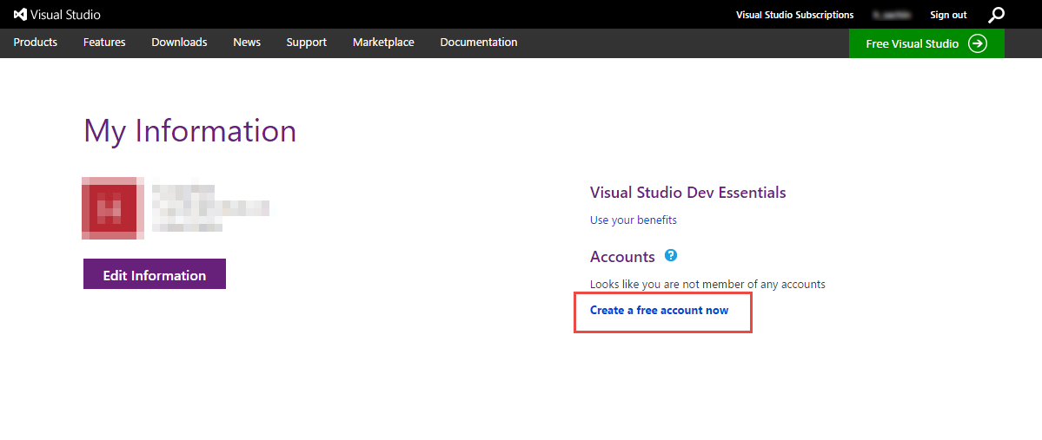

Once you do this, the experience you get might vary. If this is your very first time creating a team project, you will be prompted to create an account. Generally, you will see a screen like the following.

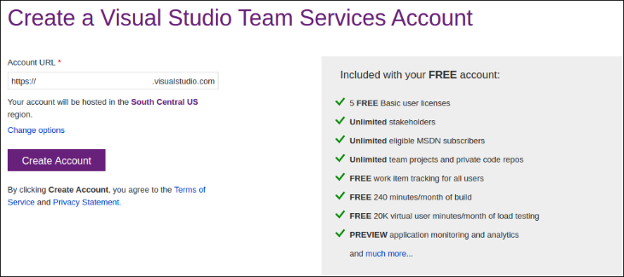

1. Enter a value in the **Account URL** field. It is possible you might have to try a couple different names.
2. Click the **Change Options** link.

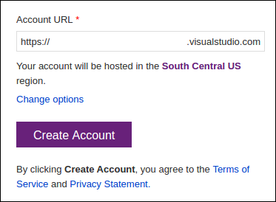

1. Select the appropriate region.

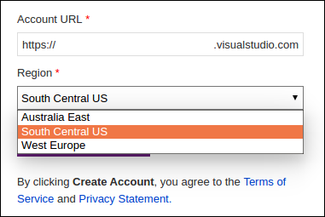

1. Click the **Create Account** button.

If you have picked an account name in use, you will receive a warning. Pick a different name and try again.

Creating a new account is typically fast and can take as little as a few seconds to complete. Once done, you will be directed to the **Create your first project** page that helps you create your first Team Project. Continue to the steps after the following screen shot to fill in the details.

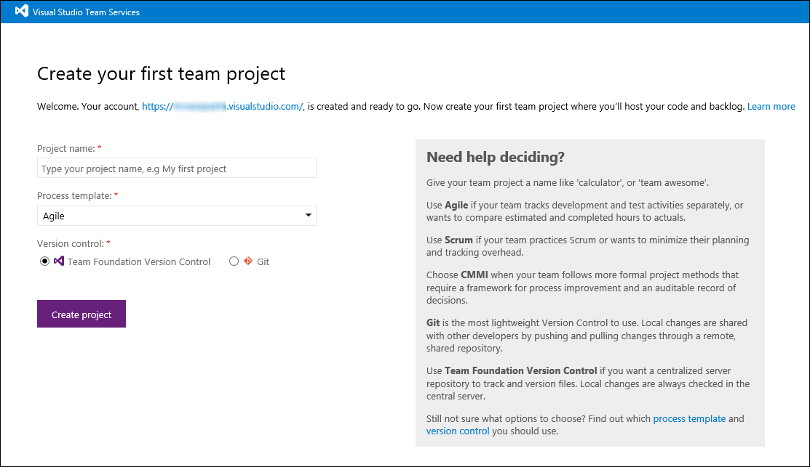

1. Enter **jdev** in the **Project name** field for your Team Project. If you use **jdev** while you are doing in this lab, your screen will match the screen shots and instructions here.
2. Select the **Scrum** process template. This is required.
3. Select **Git** for Version Control. This is also required.
4. If you are provided the option, place a check next to **Create a README.md file to describe the project**. If you do not get the option, there is nothing to worry about. Just continue.

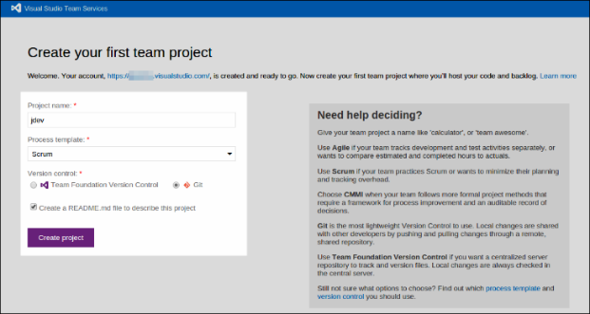

1. Click **Create Project**.

Visual Studio Team Services queues up a job to build your Team Project and, once again, in as little as a few seconds, you will have a new Team Project.

1. Once done, you should be at your CODE hub in your Team Project. Continue reading if you don’t see a screen like below.

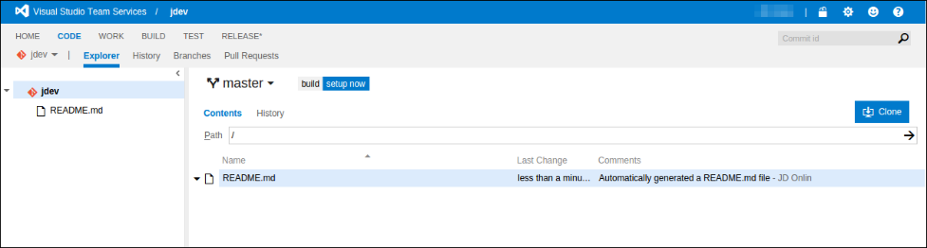

1. If you don’t see the CODE hub but instead see a dialog like the following, click **Add code**. If you just see your Team Project’s home page, click the CODE hub link and continue.

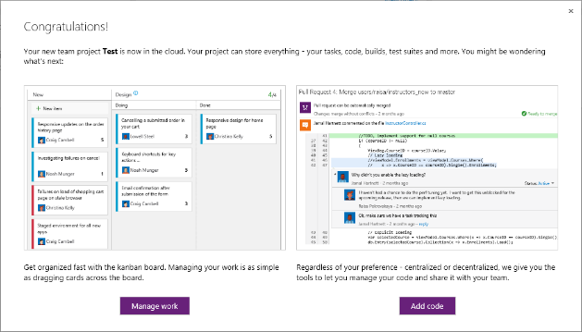

1. If your CODE hub looks a bit different than the figure from earlier (usually because you don’t have a README.md), click the **Create a ReadMe file** button. Once you’ve done this, you’re ready to continue on.

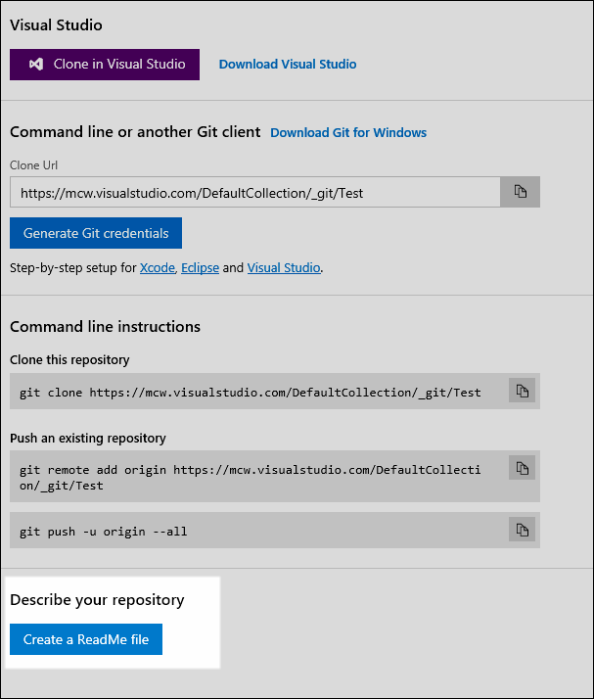

## Enabling alternate credentials

In order to access the remote repo from Eclipse, you need to enable alternate credentials.

1. In the upper right corner, click you name (1) which opens a drop down menu, and then click the **My profile** (2) menu option.

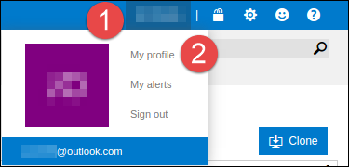

On the new page, click the **Security** link under **Details**.

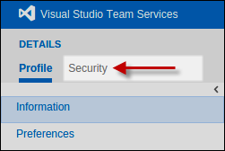

1. Next click the **Alternate authentication credentials** link.
2. Place a check next to **Enable alternate authentication credentials**.

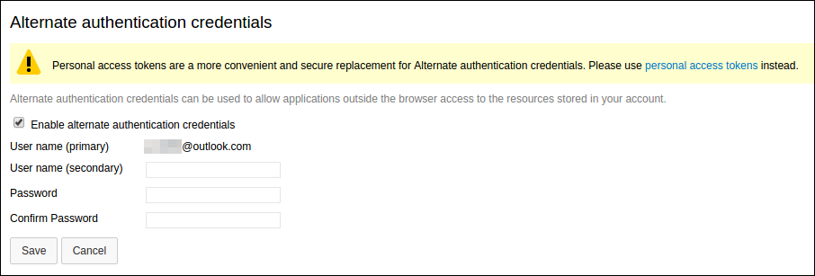

1. Next fill in the **User name (secondary)** (don’t use an e-mail address), **Password**, and **Confirm Password** fields and click **Save**.
2. Click the **Visual Studio Team Services** logo to return to your account home page.
3. The click your Team Project name under the **Recent projects & teams** list.

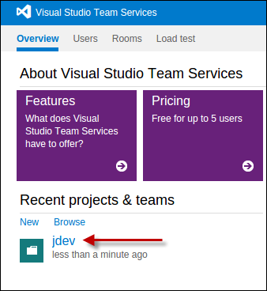

Now you’re going to manage your backlog with Visual Studio Team Services. You can read more about account creation and more at <https://www.visualstudio.com/get-started/setup/connect-to-visual-studio-online> .

To give feedback please write to [devopsdemos@microsoft.com](mailto:devopsdemos@microsoft.com)

Copyright © 2016 by Microsoft Corporation. All rights reserved.